🪟 For Windows

✅ Step 1: Download Java (JDK)
- Go to the Oracle JDK Download page or use OpenJDK.
- Download the Java SE Development Kit (JDK) for Windows.
- Run the installer and complete the installation.
📍 By default, JDK installs to:
C:\Program Files\Java\jdk-<version>

✅ Step 2: Set Environment Variables

🛠 Set JAVA_HOME
- Right-click on This PC → Properties
- Click Advanced system settings
- Click Environment Variables
- Under System variables, click New:
  - Variable name: JAVA_HOME
  - Variable value: C:\Program Files\Java\jdk-<version>
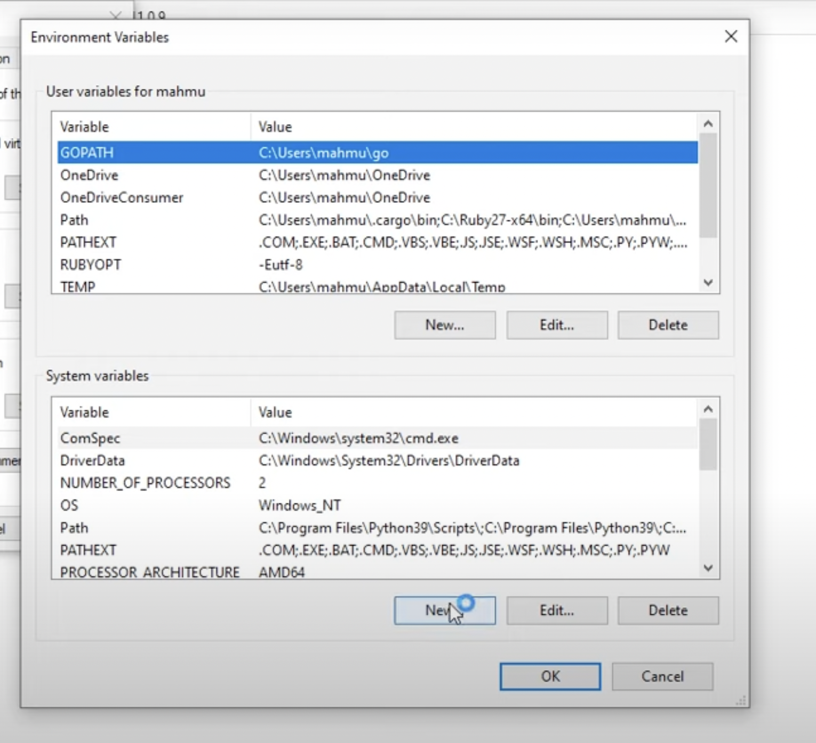

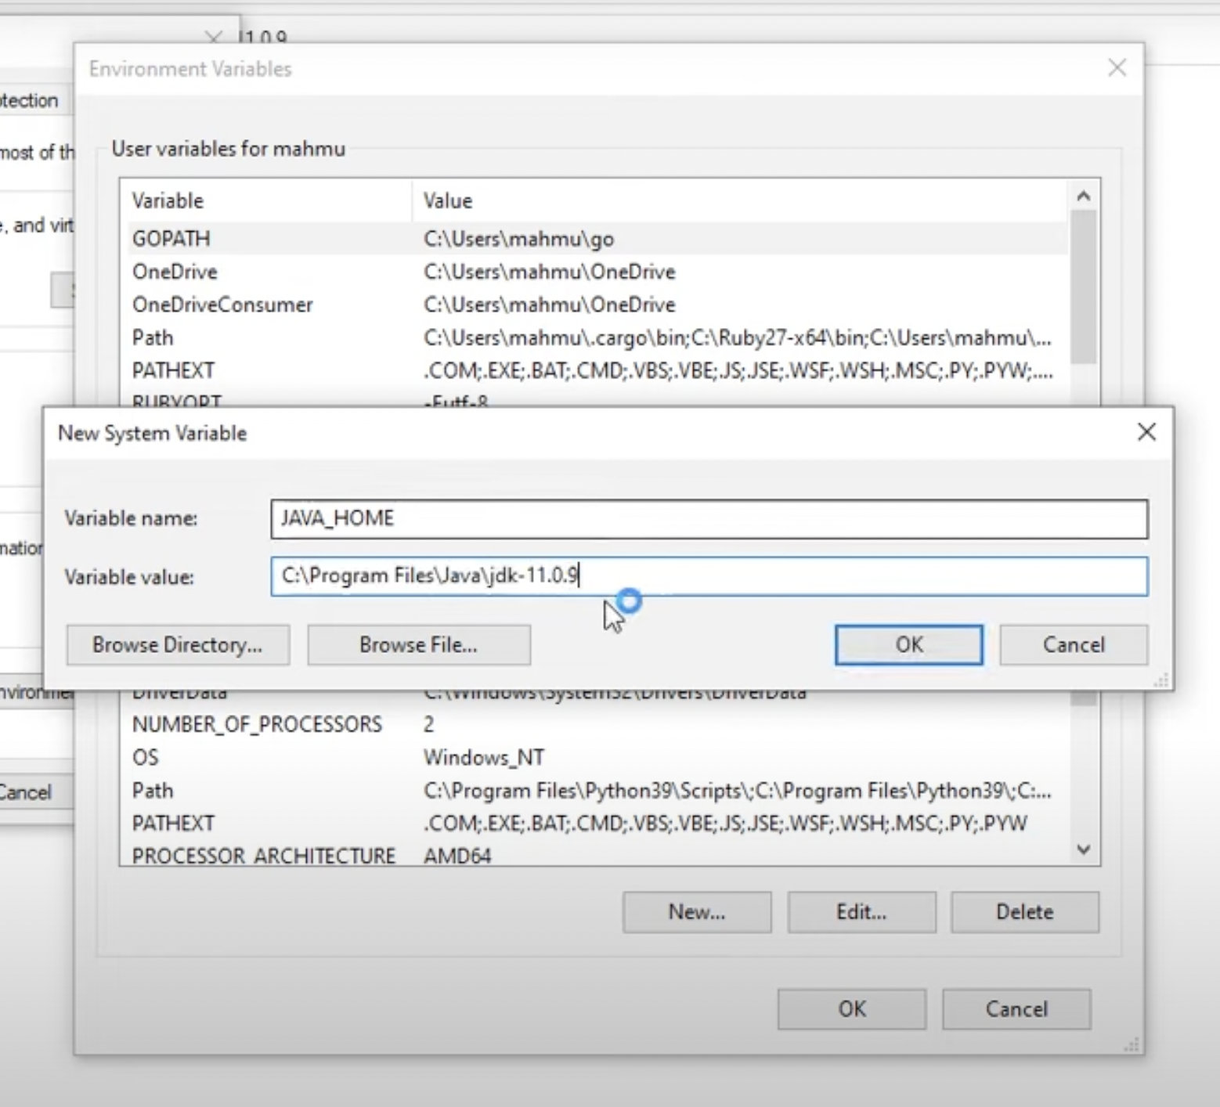

🛠 Add Java to PATH
- In the same Environment Variables window:
- Find the Path variable under System variables, and click Edit
- Click New and add:
%JAVA_HOME%\bin
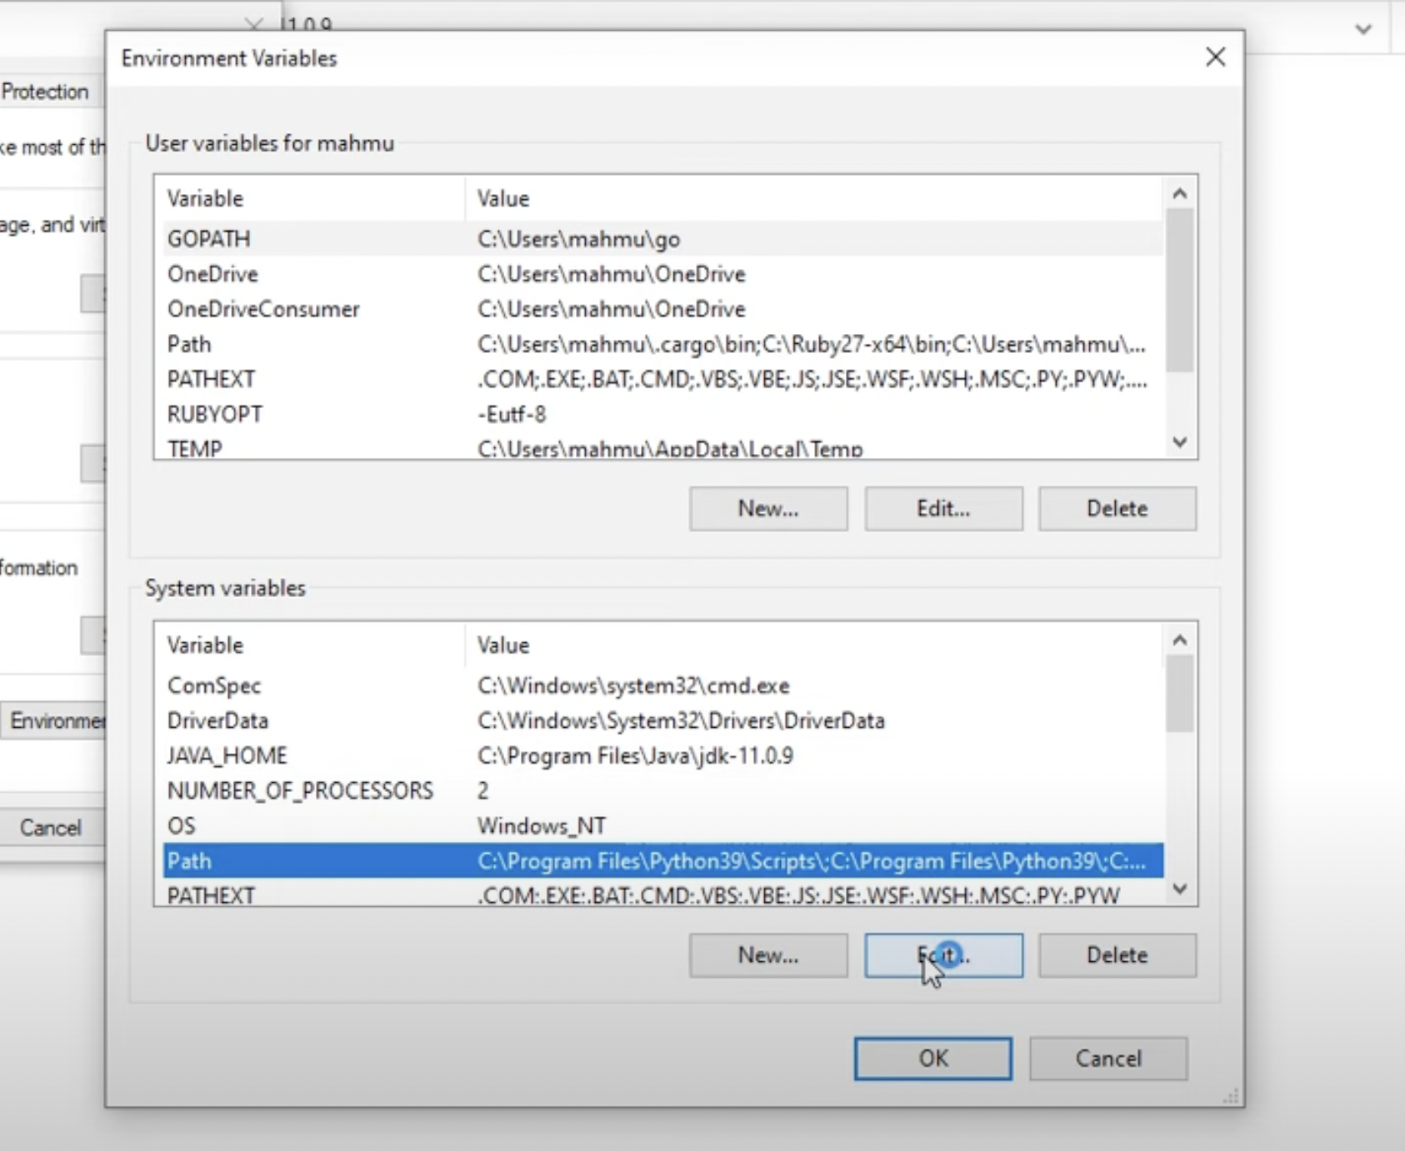
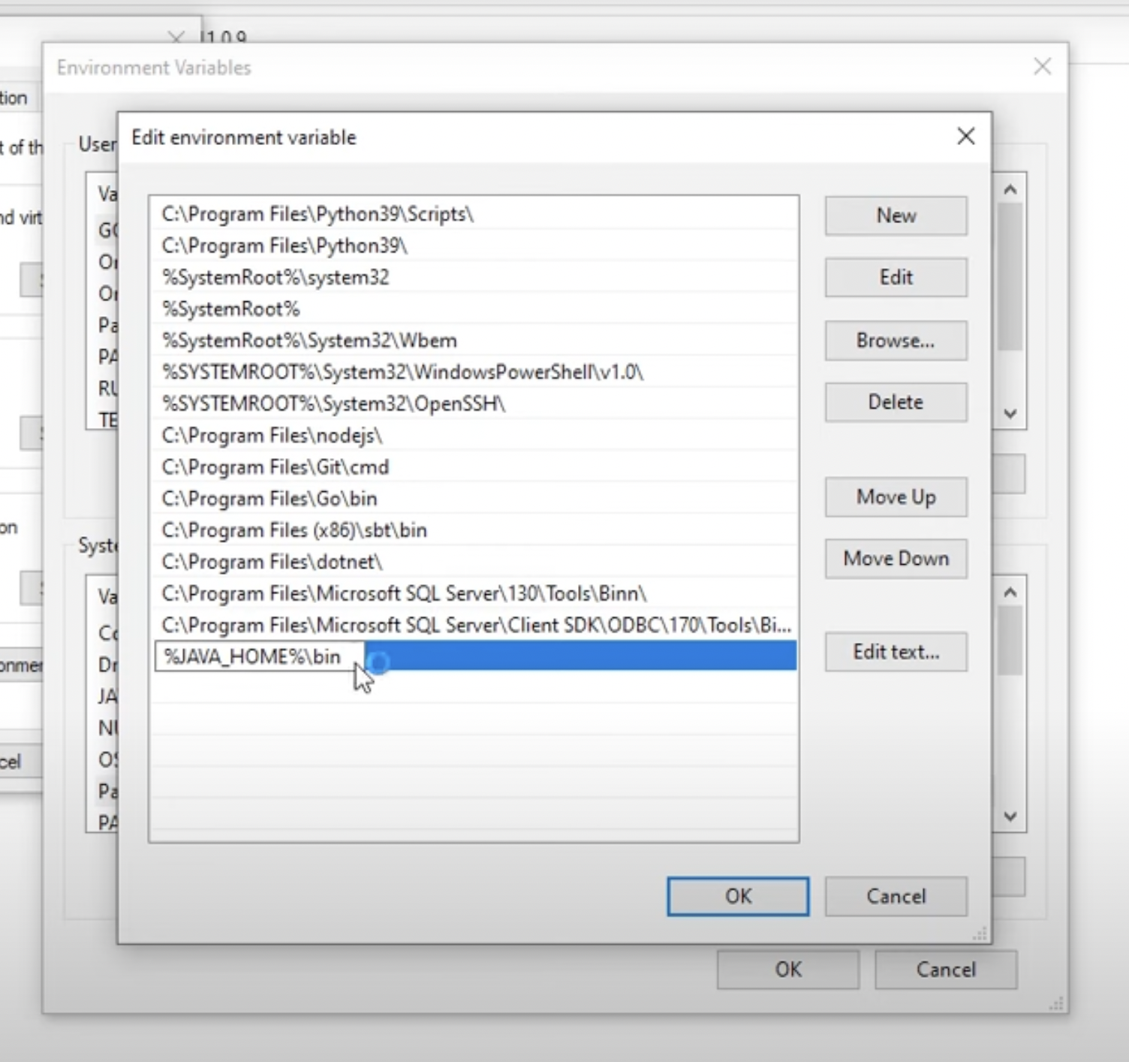

✅ Step 3: Verify Installation
Open Command Prompt and run:
java --version
javac --version

You should see the installed version printed.

